**Mockito-Hands on**

**Exercise 1: Mocking and Stubbing**

**pom.xml (for dependencies)**

<project xmlns="http://maven.apache.org/POM/4.0.0"

xmlns:xsi="http://www.w3.org/2001/XMLSchema-instance"

xsi:schemaLocation="http://maven.apache.org/POM/4.0.0 http://maven.apache.org/xsd/maven-4.0.0.xsd">

<modelVersion>4.0.0</modelVersion>

<groupId>org.example</groupId>

<artifactId>MockitoExercise</artifactId>

<version>1.0-SNAPSHOT</version>

<dependencies>

<!-- JUnit 5 -->

<dependency>

<groupId>org.junit.jupiter</groupId>

<artifactId>junit-jupiter</artifactId>

<version>5.10.0</version>

<scope>test</scope>

</dependency>

<!-- Mockito -->

<dependency>

<groupId>org.mockito</groupId>

<artifactId>mockito-core</artifactId>

<version>5.12.0</version>

<scope>test</scope>

</dependency>

</dependencies>

<build>

<plugins>

<plugin>

<groupId>org.apache.maven.plugins</groupId>

<artifactId>maven-surefire-plugin</artifactId>

<version>3.1.2</version>

</plugin>

</plugins>

</build>

</project>

**ExternalApi.java**

public interface ExternalApi {

String getData();

}

**MyService.java**

public class MyService {

private ExternalApi api;

public MyService(ExternalApi api) {

this.api = api;

}

public String fetchData() {

return api.getData();

}

}

**MyServiceTest.java**

import org.junit.jupiter.api.Test;

import static org.junit.jupiter.api.Assertions.assertEquals;

import static org.mockito.Mockito.*;

public class MyServiceTest {

@Test

public void testExternalApi() {

ExternalApi mockApi = mock(ExternalApi.class);

when(mockApi.getData()).thenReturn("Mock Data");

MyService service = new MyService(mockApi);

String result = service.fetchData();

assertEquals("Mock Data", result);

}

}

Output:

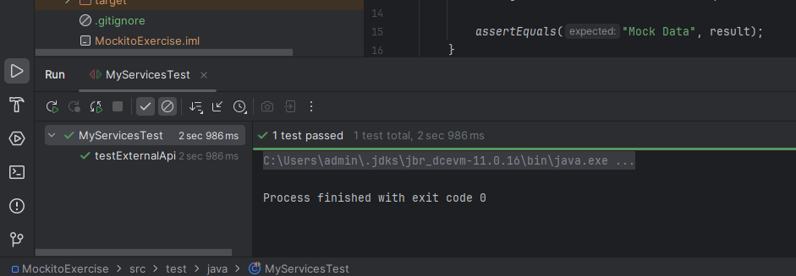

**Exercise 2: Verifying Interactions**

@Test  
public void testVerifyInteraction() {  
 ExternalApi mockApi = *mock*(ExternalApi.class);  
  
 MyService service = new MyService(mockApi);  
 service.fetchData();  
  
 // ✅ Check if getData() was called on the mock  
 *verify*(mockApi).getData();  
}

